Experiment 5: Breadth First Search (BFS)
Aim
To implement Breadth First Search (BFS) using Python.
Objective
To traverse all nodes of a graph using BFS.
Algorithm
- Create a graph.
- Select the starting node.
- Visit the node.
- Add its neighbours to the queue.
- Repeat until the queue is empty.
Flowchart
Start
|
Create Queue
|
Visit Node
|
Add Neighbours
|
Queue Empty?
/ \
No Yes
| |
Repeat Stop
Code
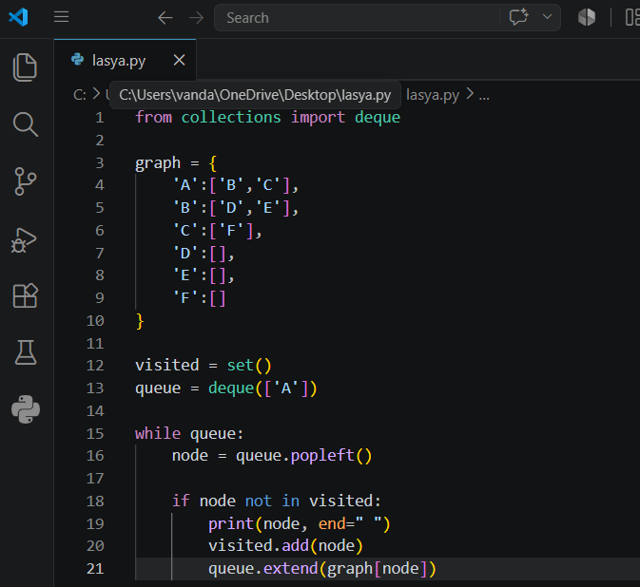
Output
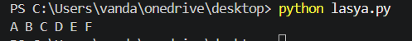
Result
The graph was traversed successfully using BFS.
Conclusion
The BFS algorithm visits all nodes level by level using a queue.

